**THIẾT KẾ XÂY DỰNG PHẦN MỀM**

**Nhóm SIE.TKXDPM-05**

**Lớp: LTU15**

Hoàng Quốc Huy 20168228

**HOMEWORK 05**

# A. Thiết kế giao diện

## 1. Screen Transition Diagram

*Hình 1: Sơ đồ chuyển đổi màn hình*

## 2. Screen Specification

Import Management Screen:

|  |  |  |  |
| --- | --- | --- | --- |
| Screen | Control | Operation | Function |
|  | Area for displaying list table | Initial | Display the overall information of an order that was made by the Sale Employee |
| Detail Button | Click | Display the other screen to show the detail of the order bill |
| Update Button | Click | Display the other screen to update the value of the order |
| Create Button | Click | Display the other screen to create the value of the order |
| Delete Button | Click | Display the other screen to delete the value of the order |

Order Detail Screen:

|  |  |  |  |
| --- | --- | --- | --- |
| Screen | Control | Operation | Function |
|  | Area for displaying list table | Initial | Display the detail information of an order that was made by the Sale Employee |
| Create Button | Click | Save the create order |
| Update Button | Click | Confirm the update value |
| Received Button | Click | Change the state of the order in database |
| Exit Button | Click | Exit out of the current screen |

## 3. Defining Field Attribute

Import Management:

|  |  |  |
| --- | --- | --- |
| Item name | Type | Remarks |
| Import Order Code | Character | The id of the order bill |
| Sale Employee Code | Character | The id of the Employee who take the responsibility |
| Create Time | TimeStamp | Time mark when the order was created |
| Update Time | TimeStamp | Time mark when the order was updated |

Detail Order:

|  |  |  |
| --- | --- | --- |
| Item name | Type | Remarks |
| Merchandise Code | Character | The id merchandise |
| Quantity Ordered | Character | The number of merchandise that the Sale Employee need for the customer |
| Unit | Charater | The currency of the merchandise |
| Desired Date | TimeStamp | Time mark of the date customer want to received the merchandise |

# B. Class Design

Class Design Import Management:

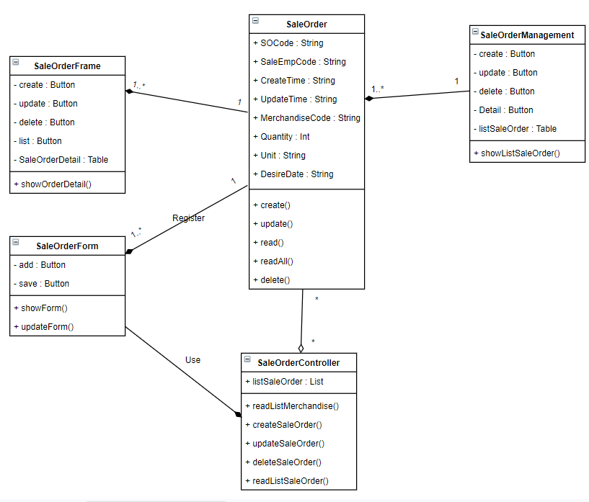

# C. Data Modeling

